**Bus Matrix for Business prosses, dimensions**

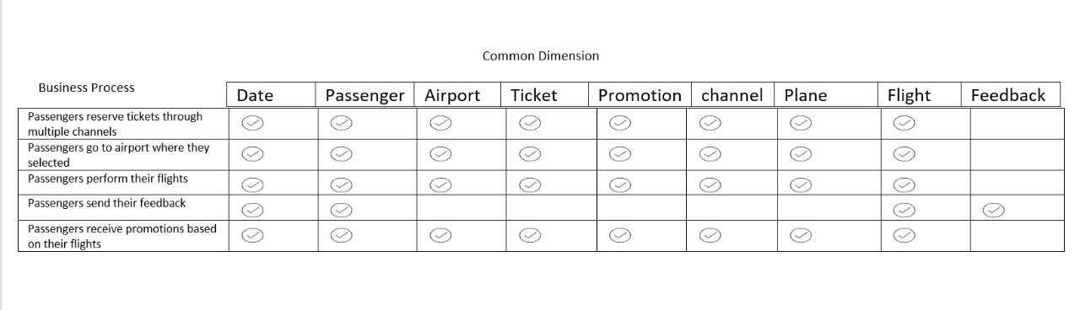

**Logical data model:**

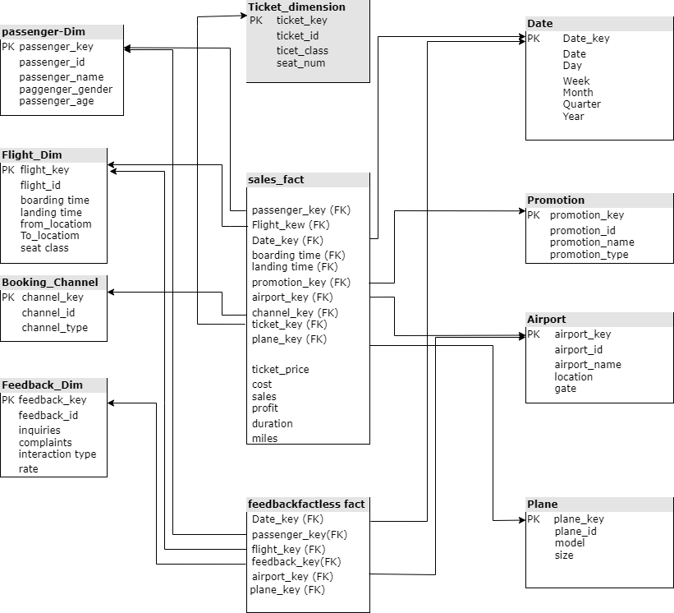

**logical model details: -**   
-we choose this data model design (Galaxy Schema) as case study has more than one fact table.

**Business case**: analyze current business processes and expand the company (flight activity, profit)  
  
**Grain**: per ticket (atomic)  
  
**Facts**: Ticket-sales, Feedback  
  
**Dimensions**: Date, Flight, Passenger, Airport, Booking-Channel, Promotion, Plane, Ticket   
  
  
Details about each table   
**Ticket-sales Fact**: include information about Booking(ticket) such as passenger ID, flight ID, date of booking, booking channel, ticket no, airport ID , Promotion ID, time of boarding and landing, price of ticket, duration of flight, miles of flight to add promotion   
**Feedback Fact:** include information about opinion of customer for flight such as passenger ID, flight ID, date of booking, feedback id, plane id (it’s a fact less fact table as it doesn’t have measures)   
**Data Dimension**: include date, day, week, month, quarter, year.  
**Passenger Dimension**: include information about each Passenger, such as Passenger id, name, address, phone, gender, and age.   
**Flight Dimension:** include information about each flight, such as flight id, boarding time, landing time, from / to location, seat no   
**Airport Dimension:** include information about each airport, such as airport id, name, location, gate.  
**Booking-channel Dimension:** include information about each channel such as channel id, type   
**Ticket Dimension:** include information about each ticket such as ticket id, class of ticket, upgrade of ticket (that’s slowly changing dimension as data update over time)   
**Promotion Dimension:** include information about each promotion such as promotion id, name, type.   
**Plane Dimension:** include information about each plane such as plane id, model, size.  
**feedback Dimension:** include information about each feedback such as rate or complaint before, within and after the flight.